CASH FLOW

2020 Project Charter

|  |  |  |  |
| --- | --- | --- | --- |
| **Project Charter Version Control** | | | |
| **Version No.** | **Date** | **Author** | **Description of Changes** |
| 1.0 | 02/11/20 | E. Proulx | Initial Draft |
| 1.1 | 2/12/20 | E. Proulx | Updates to scope, assumptions and dependencies based on meeting with Data Analytics and Data Governance |
| 1.2 | 2/20/20 | E. Proulx | Updates to Dependencies, team members and updated initial timeline |
|  |  |  |  |
|  |  |  |  |

# PURPOSE OF CHARTER

The project Charter is used to understand the ***objectives***, ***scope***, and certain project parameters such as ***roles and responsibilities, assumptions and constraints.*** More specifically, this charter should accomplish:

* Developing a common understanding of the project and all its components (in-scope)
* Securing commitment (approval and support) from the Key Project Stakeholders

# Problem/Opportunity statement

In the Fall of 2017, RiverStone defined the need for an application where Asbestos Claims Analysts could enter Cash Flow projections for their claims. The Cash Flow project team captured requirements and built an application to support the MVP product to meet the initial needs. Since that time, the scope and needs for the Cash Flow application have grown: there are more users because we Cash Flow Asbestos, Pollution/Health Hazzard, and Liability; the application needs to support a much larger data set; additional business groups use the data for their needs, such as the Finance team for monthly reporting to Fairfax.

In this 2.0 phase of the Cash Flow project, the goal is to ensure there is sound technology to support the application on an ongoing basis, reduce the time it takes to make entries and produce reports, enhance the features of the application to meet new and changing business needs, and provide management with the tools needed to make key decisions.

The fundamental goals that Cash Flow must allow RiverStone to achieve are:

* Determining monthly liquidity
* More details / thinking and planning around Claims Management
* Reserve Planning and giving leadership the means to deliver a “Big Picture” view

# scope

**3.1 In Scope**

The Success of the Project in 2020 is dependent on the following deliverables that have been deemed as in-scope:

* + ***Net Calculation*** 
    - Design and build automated process through Sapiens for Net Calculations
    - Be able to report on the Net Calculations
    - Build a template which will allow both Cash Flow and other figures to flow through the process (MVP for Capital Projection Engine (aka Sandbox/Scenario Testing Tool)
    - Making the Net Calculation process automated through Sapiens will reduce the time it takes to produce the Net values manually, and makes the data centralized, removing the need to add multiple spreadsheets together. Using Sapiens is also beneficial because it is our system of record for this data.
  + ***Faster Reporting***
    - Take an inventory of existing Cash Flow reports and determine which will remain, which need to be changed, and any new reports
    - Build a Data Mart which will house the Cash Flow and supporting data elements to populate the reports
    - Build the reports out to PowerBI
    - Remove the need to run the CFDA process after entries are completed in order for the data to be reported on
    - Readily available data will allow for management to have the reports more quickly with the right level of supporting details. We may even be able to eliminate other reports that management is manually combining with Cash Flow reports which will save them time and ensure the data is accurate.
  + ***Application Enhancements*** 
    - Enhancements to technical processes to support a smoother application function (i.e. release process)
    - Re-do the permissions and user structure based on the Data Governance manager table
    - Work with key business SMEs to define top priority user stories of a smaller complexity to implement in the application to make it more usable with better entry and workflow
    - A more user-friendly app which captures the necessary details for the entries will decrease the time users need to make entries, and lessen the time needed to talk about the entries with management because the details will be captured in the data.
  1. **Out of Scope**

This Program will ***not*** include any of the following:

1. Changing the application and reporting to 18 rolling calendar months
2. Assumed Claims
3. Claims outside of ClaimCenter
4. Data Mart relative to any other reports outside of Cash Flow; including the Claims Daily report and IGR report
5. Net reporting on anything other than APO claims in ClaimCenter

# critical success factors

**4.1 Assumptions**

*[Briefly describe any known assumptions that are relevant. For planning purposes, assumptions are factors that are taken for granted or accepted as being true. Often, assumptions imply a degree of risk.]*

The success of this project assumes:

* Users will continue to manually update the Excel sheet for Finance to report calendar month Cash Flow to Fairfax
* The sources for the Data Mart are considered tactical in order to complete the work in the timeframe for this project; sources will likely change once the D3 project is complete
* Resources to do the in-scope work are available and allocated to the project in support of the timeline
* Current Cash Flow reporting process will run concurrently with the new process to validate output/results
  1. **Dependencies**

*[Briefly describe any known dependencies for the success of the project. Dependencies are factors that are determined, controlled, or influenced outside of the project’s span of control.]*

Successful completion and delivery of this project is dependent on:

* + Dependency on Data Governance for definition of segmentations
  + Dependency on Data Governance for Manager Table for both user hierarchy in the application and for reporting

# Risks

* Data Governance is responsible for definition of segmentations; will use the current definition for Actuarial segment that has been used for Cash Flow reporting to date

# key project stakeholders

|  |  |  |
| --- | --- | --- |
| **Key Stakeholder** | **Role** | **Need/Impact** |
| Bob Sampson | Business Stakeholder | Approval of Charter; Approval of all Ins Ops resources needed; keep informed of progress, blockers, status |
| Karen Malmquist | Technology Stakeholder | Approval of Charter; Approval of all Technology resources needed; keep informed of progress, blockers, status |
| Tim Donlon | Business Decision Maker | Decision Maker for all Projects herein |
| Maureen Tymochko | Project IT Lead | Manages and Reports on all Projects herein |

# team roles & responsibilities

|  |  |  |
| --- | --- | --- |
| **Resource** | **Role** | **Responsibility** |
| Emily Proulx | Product Owner | Delivery of all Projects; assist in requirements gathering; assist in testing |
| Courtney Joyce | Scrum Master | Scrum Master for all Projects; assist in requirements gathering; assist in testing |
| Maureen Tymochko | RTS Lead | Provide oversight on behalf of RTS leaders |
| Michael Ban  Scott St Onge  Joe Winbigler  Ragulan Vithurpan | Business Analytics | Technical data leads and developers |
| Tim Donlon  Michael Bryant  Ivan Jaffa | Insurance Operations Business Leads | Responsible for key business decisions for Insurance Operations |
| Kelly Porter  Kevin Chenelle | Insurance Operations SMEs | Provide input for requirements and perform UAT for Application Enhancements |
| Phil Simpson | Reinsurance SMEs for Net Calculation | Lead on process for Net Calculations |
| Corey Rousseau | Actuarial SME | Partner/consultant for data consistency |
| Akhila Sudarshan | Quality Engineer and Business Analyst | Requirements and testing |
| Vijay Kapuluru | Developer | Lead developer on Sapiens for Net Calculation |
| Dave Ickes | Developer | Lead developers on Application Enhancements |
| Jason Edwards | Production Support Manager | Run processes and define where manual processes can be automated |

# project management, Milestones & metrics

This project will operate and be managed according to Agile principles and methodology. Each of the Projects within will have milestones and metrics that will be reported on. As epics and userstories are created and sized, these milestones and metrics will be communicated, and this documented will be updated.

# projected initial timelines

While this project will be run according to Agile principles and practices, below are estimated initial timelines for each of the deliverables. As epics and user stories are created and worked through JIRA, timelines will be drilled into for a better estimate of project delivery dates. Timelines and timeline adjustments will be communicated to stakeholders and scrum teams monthly.

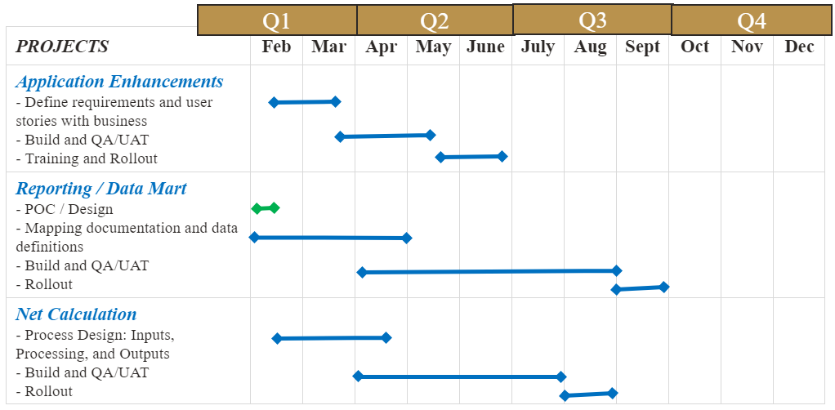

# approval

The below Stakeholders agreement with the content of this Charter and support to move forward with the project.

|  |  |  |  |  |
| --- | --- | --- | --- | --- |
| **Key Stakeholder** | **Role** | **Signature** | **Comments** | **Date** |
| Bob Sampson | Business Stakeholder |  |  |  |
| Karen Malmquist | Technology Stakeholder |  |  |  |
| Tim Donlon | Business Decision Maker |  |  |  |

*[Note: Please use the project change control log to indicate changes in the authorized project approver(s) that occur after the Charter approval.]*